**SCHEMES OF WORK FOR BASIC 8 THIRD TERM (OMEGA TERM)**

**WEEK 1 REVISION OF SECOND TERM’S**

**WEEK 2 DISTANCES AND TIME, REAL LIFE GRAPH**

**WEEK 3 ANGLES AND POLYGON**

**WEEK 4 ANGLES OF ELEVATION AND DEPRESSION**

**WEEK 5 STATISTICS**

**WEEK 6 STATISTICS**

**WEEK 7 REVIEW OF FIRST HALF TERM’S**

**WEEK 8 PROBABILITY**

**WEEK 9 PROBABILITY**

**WEEK 10 REVIEW OF SECOND TERM’S WORK**

**WEEK 11 REVISION**

**WEEK 12 EXAMINATION**

**WEEK 1 AND 2 DISTANCES AND TIME, REAL LIFE GRAPH**

# How Do You Graph a Linear Equation by Making a Table?

### Note:

Graphing a function? It would be really helpful if you had a table of values that fit your equation. You could plot those values on a coordinate plane and connect the point to make your graph. See it all in this tutorial!

* + - [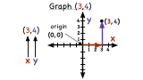](http://www.virtualnerd.com/algebra-1/relations-functions/coordinate-plane/coordinate-plane-graphing/coordinate-plane-graph-points-example)

#### [How Do You Plot Points in the Coordinate Plane?](http://www.virtualnerd.com/algebra-1/relations-functions/coordinate-plane/coordinate-plane-graphing/coordinate-plane-graph-points-example)

Knowing how to plot ordered pairs is an essential part of graphing functions. In this tutorial, you'll see how to take an ordered pair and plot it on the coordinate plane. Take a look!

* + - [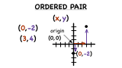](http://www.virtualnerd.com/algebra-1/relations-functions/coordinate-plane/coordinate-plane-graphing/ordered-pair-definition)

#### [What is an Ordered Pair?](http://www.virtualnerd.com/algebra-1/relations-functions/coordinate-plane/coordinate-plane-graphing/ordered-pair-definition)

Ordered pairs are a fundamental part of graphing. Ordered pairs make up functions on a graph, and very often, you need to plot ordered pairs in order to see what the graph of a function looks like. This tutorial will introduce you to ordered pairs!

* + - [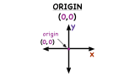](http://www.virtualnerd.com/algebra-1/relations-functions/coordinate-plane/coordinate-plane-graphing/origin-definition)

#### [What is the Origin?](http://www.virtualnerd.com/algebra-1/relations-functions/coordinate-plane/coordinate-plane-graphing/origin-definition)

The coordinate plane has two axes: the horizontal and vertical axes. These two axes intersect one another at a point called the origin. Learn about the ordered pair that indicates the origin and its location in the coordinate plane by watching this tutorial!

* + - [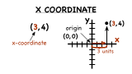](http://www.virtualnerd.com/algebra-1/relations-functions/coordinate-plane/coordinate-plane-graphing/)

#### [What is the X-Coordinate?](http://www.virtualnerd.com/algebra-1/relations-functions/coordinate-plane/coordinate-plane-graphing/)

Ordered pairs are a crucial part of graphing, but you need to know how

#### Identifying Linear Equations

* + - [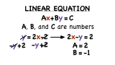](http://www.virtualnerd.com/algebra-1/relations-functions/graphing-linear-equations/identifying-linear-equations/linear-equation-standard-form-definition)

#### [What's Standard Form of a Linear Equation?](http://www.virtualnerd.com/algebra-1/relations-functions/graphing-linear-equations/identifying-linear-equations/linear-equation-standard-form-definition)

A linear equation can be written in many different forms, and each of them is quite useful! One of these is standard form. Watch this tutorial and learn the standard form for a linear equation!

### Further Exploration

#### Working With Graphs

* + - [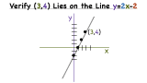](http://www.virtualnerd.com/algebra-1/relations-functions/graphing-linear-equations/graphs-examples/check-point-line-graph)

#### [How Do You Check if a Point is on a Line If You Have a Graph?](http://www.virtualnerd.com/algebra-1/relations-functions/graphing-linear-equations/graphs-examples/check-point-line-graph)

Wonder if a point is part of a line? You could take that equation and graph it. Then use the graph to get your answer! Watch how in this tutorial.

#### Finding Slopes

* + - [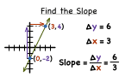](http://www.virtualnerd.com/algebra-1/linear-equation-analysis/slope-rate-of-change/slope-examples/slope-from-graph)

REAL LIFE GRAPH

**WEEK 3 ANGLES AND POLYGON**

### TYPES AND PROPERTIES OF ANGLES

Straight Angles

Angles which measure exactly 180° (degrees) are straight angles. Therefore, straight angles are straight lines. Angles are represented by the sign ϴ, called theta. That is, for straight angles, ϴ= 180°.

[http://wizznotes.com/wp-content/uploads/2011/01/image0011.jpg](http://wizznotes.com/wp-content/uploads/2011/01/image0011.jpg)

Right Angles

Angles which measure exactly 90° are right angles, that is, ϴ = 90°.

[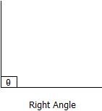](http://wizznotes.com/wp-content/uploads/2011/01/image0022.jpg)

Obtuse Angles

Obtuse angles are those which are greater than 90° but less than 180°, that is, 90° < ϴ < 180°.

[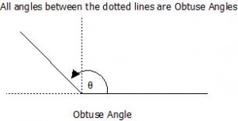](http://wizznotes.com/wp-content/uploads/2011/01/image0031.jpg)

Acute Angles

Acute angles are angles which are greater than 0° but less than 90°, that is, 0° < ϴ < 90°.

[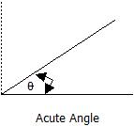](http://wizznotes.com/wp-content/uploads/2011/01/image0042.jpg)

Reflex Angles

Reflex angles are angles which are greater than 180° but less than 360°, that is, 180° < ϴ < 360°.

[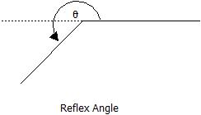](http://wizznotes.com/wp-content/uploads/2011/01/image005.jpg)

Adjacent Angles

Two angles which share the same vertex (centre, usually represented by 0) and have a common side (line) are called adjacent angles.

[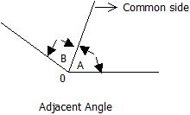](http://wizznotes.com/wp-content/uploads/2011/01/image0062.jpg)

Complementary Angles

Complementary angles are two angles which when summed equals 90°.

[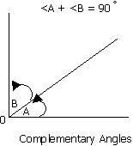](http://wizznotes.com/wp-content/uploads/2011/01/image007.jpg)

Note: <A and <B, are ‘angle A’ and ‘angle B’ respectively.

Supplementary Angles

Supplementary angles are two angles which when summed equals 180°.

[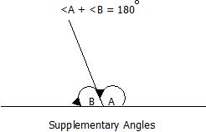](http://wizznotes.com/wp-content/uploads/2011/01/image0082.jpg)

Vertically Opposite Angles

Vertically opposite angles are the angles opposite to each other when two straight lines intersect. Their defining property is that, vertically opposite angles are equal in magnitude.

[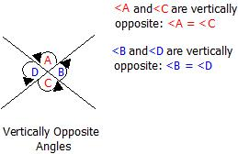](http://wizznotes.com/wp-content/uploads/2011/01/image009.jpg)

Corresponding Angles

When two parallel lines are crossed by a line called the transversal, the angles formed which are in corresponding positions, are called corresponding angles. Corresponding angles are equal in magnitude.

[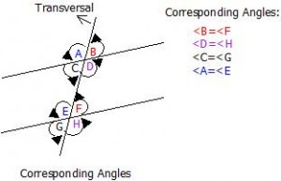](http://wizznotes.com/wp-content/uploads/2011/01/image010.jpg)

**EXAMPLES: Calculate the size of the marked angle in the diagram below**

**560  950**

**470 x 950  780 x**

**POLYGON:** A part from triangle and quadrilateral, we have other polygons which are also named according to the number of sides they have.

Examples are pentagon = 5, Hexagon = 6. It can be regular or irregular. **A polygon is said to be regular when all the sides and angles are equal. An irregular polygon has neither of the sides or angles equal.**

**TYPES OF POLYGON (Regular Polygons)**

Regular polygons have all sides, and all angles equal.

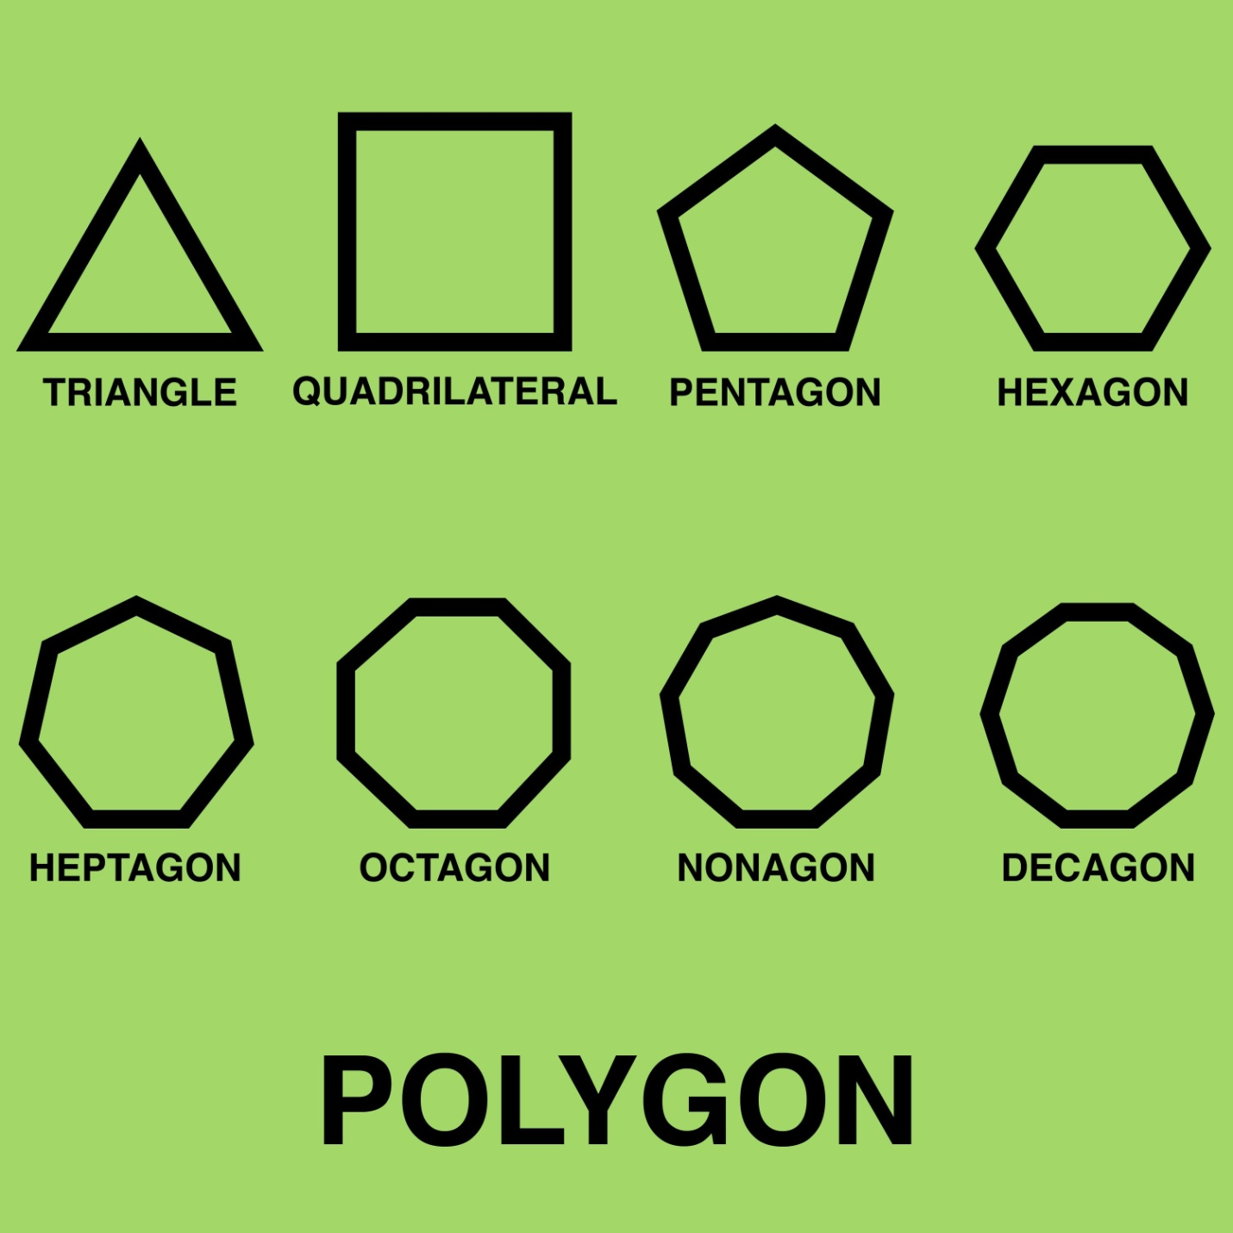

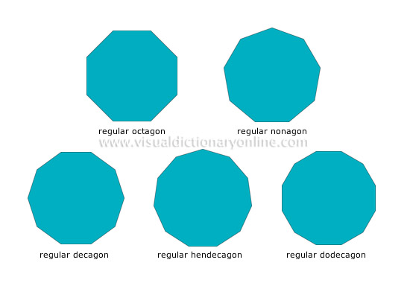

Size of Internal Angles

To find the size of the internal angles of a regular polygon with ‘n’ sides, use the formula:

[http://wizznotes.com/wp-content/uploads/2011/02/Internal-angle1.jpeg](http://wizznotes.com/wp-content/uploads/2011/02/Internal-angle1.jpeg)

For example, the size of the interior angles of the pentagon (five sides) above is:

[http://wizznotes.com/wp-content/uploads/2011/02/Internal-angle2.jpeg](http://wizznotes.com/wp-content/uploads/2011/02/Internal-angle2.jpeg)

The sum of all the interior angles of a polygon with ‘n’ sides is found using the formula:

(n – 2)  x  180°

Therefore, the sum of all the interior angles of the pentagon above is:

(5 – 2)  x 180°  =  3  x 180°  =  540°

Size of Exterior Angles

Interior and Exterior angles are measured on the same line, that is, they add up to 180°.

Therefore, the size of an exterior angle =  180° – Interior angle.

For example, the size of the external angle of the pentagon above is:

Since, interior angle = 108°

Then, exterior angle =  180° – Interior angle

180° – 108° =  72°

Below is a list of the names and the number of sides, of some of the most popular polygons.

|  |  |
| --- | --- |
| **Name of Polygon** | **Number of Sides** |
| Equilateral Triangle | 3 |
| Quadrilateral | 4 |
| Pentagon | 5 |
| Hexagon | 6 |
| Heptagon | 7 |
| Octagon | 8 |
| Nonagon | 9 |
| Decagon | 10 |

DO THESE:

* 1. Calculate the total internal angle of an octagon
  2. The size of each angle of a regular octagon
  3. The total internal of decagon
  4. The size of each angle of a regular decagon.

ASSIGNMENT:

PAGE 233 EXERCISE 18.3 QUESTION 1 TO 10 OF ESSENTIAL MATHEMATICS FOR JUNIOR SECONDARY SCHOOLS BOOK 2

**WEEK 4 ANGLES OF ELEVATION AND DEPRESSION**

**What is angle of elevation?**  
The **angle of elevation** is the angle between a horizontal line from the observer and the line of sight to an object that is above the horizontal line.

In the diagram below, AB is the horizontal line. q is the angle of elevation from the observer at A to the object at C.

A B

**What is angle of depression?**  
The **angle of depression** is the angle between a horizontal line from the observer and the line of sight to an object that is below the horizontal line.

In the diagram below, PQ is the horizontal line. q is the angle of depression from the observer at P to the object at R.

**How to solve word problems that involves angle of elevation or depression?**  
Step 1: Draw a sketch of the situation.  
Step 2: Mark in the given angle of elevation or depression.  
Step 3: Use trigonometry to find the required missing length

Example:

Two poles on horizontal ground are 60 m apart. The shorter pole is 3 m high. The angle of depression of the top of the shorter pole from the top of the longer pole is 20˚. Sketch a diagram to represent the situation.

Solution:

**Step 1**: Draw two vertical lines to represent the shorter pole and the longer pole.

**Step 2**: Draw a line from the top of the longer pole to the top of the shorter pole. (This is the line of sight).

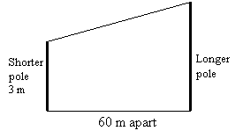

**Step 3**: Draw a horizontal line to the top of the pole and mark in the angle of depression.

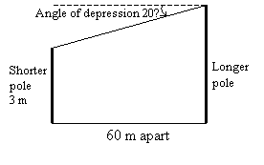

Example:

A man who is 2 m tall stands on horizontal ground 30 m from a tree. The angle of elevation of the top of the tree from his eyes is 28˚. Estimate the height of the tree.

Solution:

Let the height of the tree be h. Sketch a diagram to represent the situation.

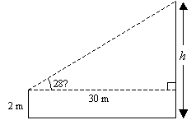

tan 28˚ = http://www.onlinemathlearning.com/image-files/angle-of-elevation9.gif

h – 2 = 30 tan 28˚

h = (30 ´ 0.5317) + 2 ← tan 28˚ = 0.5317

= 17.951

The height of the tree is approximately **17.95 m**.

**WEEK 5AND 6 STATISTICS**

**FREQUENCY TABLE**

EXAMPLE 1: The following figures show the number of children per family in a sample of 40 household. 1, 2, 4, 3, 5, 3, 8, 3, 2, 3, 4, 5, 6, 5, 4, 2, 1, 3, 2, 4, 5, 3, 8, 7, 6, 5, 4, 5, 7, 6, 3, 8, 6, 3, 5, 7, 5, 4, 3.

1. Use a tally mark to prepare a frequency table for the data
2. What is the highest frequency of numbers of children per family?

Solution

NUMBER TALLY FREQUENCY

1 // 2

2 //// 5

3 //// //// 9

4 //// / 6

5 //// /// 8

6 //// 4

7 /// 3

8 /// 3

40

3 is the highest frequency of numbers of children

Example 2: In a further mathematics test the following marks were obtained by a group of students 85, 75, 95, 80, 75, 80, 90, 84, 95, 84, 85, 80, 80, 75, 80, 75, 80, 84, 81, 80, 75, 90, 80.

Use tally mark to prepare a frequency table for this data.

Solution:

NUMBER TALLY FREQUENCY

75 //// 5

80 //// 9

81 / 1

84 /// 3

85 // 2

90 /// 3

95 // 2

1. How many students took part in the test? 25 students
2. Which mark had the highest frequency? 80 marks

**AVERAGE, MEAN MEDIAN AND MODE**

Average is a single value used to represent a set of numbers (i.e all value in as et data)

The most common ly used statistics is average.

[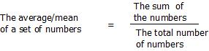](http://wizznotes.com/wp-content/uploads/2010/11/image068.jpg)

**MEDIAN = THE NUMBER AT THE MIDDLE AFTER THE ARRANGEMENT OF THE DATA.**

**MODE IS THE VALUE THAT OCCURS MOST FREQUENTLY.**

**EXAMPLES:** Calculate the mean, media and mode of the following data

1. 45, 50, 55, 54, 48, 53, 50, 55
2. 38, 35, 36, 30.8, 34.7, 37.9, 33.1
3. 3, 0,4,7, 0, 5, 3, 4, 0, 3, 6, 5, 5 ,4, 6, 5

Solution:

Mean = 45+50+ 55+ 54+ 48+ 53+ 50+ 55

8

**= 410/8**

**= 51.25**

**Median = 45, 48, 50, 50, 53, 54, 55,55**

**50 + 53**

**2**

**= 52**

**Mode = 50 and 55**

### Average

The average or mean of a set of numbers is defined by the formula:

[](http://wizznotes.com/wp-content/uploads/2010/11/image068.jpg)

Example

[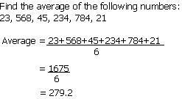](http://wizznotes.com/wp-content/uploads/2010/11/image069.jpg)

**Bar Charts**

A Bar chart is a series of rectangular bars of the same width, drawn vertically or horizontally, with an equal space between them, with the height of each bar being a depiction of the data it is representing.

Example

The table below lists several models of Blackberry cellular phones and the amount of each that an electronic store has in stock. Draw a vertical and horizontal bar chart to represent the data.

|  |  |
| --- | --- |
| **Blackberry Phones** | **Stock Amount** |
| Blackberry Curve 8310 | 75 |
| Blackberry Curve 8320 | 100 |
| Blackberry Pearl 8100 | 50 |
| Blackberry Bold 9650 | 200 |
| Blackberry Bold 9000 | 150 |
| Blackberry Curve 8520 | 125 |

[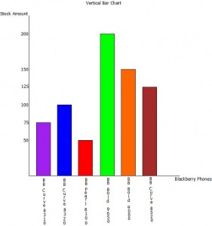](http://wizznotes.com/wp-content/uploads/2010/11/image0161.jpg)

[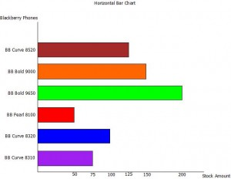](http://wizznotes.com/wp-content/uploads/2010/11/image0171.jpg)

**Pie Charts**

A Pie chart is a circular diagram divided into sectors, with the size of each sector representing the magnitude of data it is depicting. Each sector of a pie chart can either be displayed in percentages (note all sectors must add up to 100%) or as an angle (note all sectors must add up to 360o).

Example

The table below lists some of the most popular football clubs and the number of students at a given institution that supports each. Use a Pie chart to represent the information given in the table.

|  |  |
| --- | --- |
| **Football Clubs** | **Number of Students** |
| Chelsea | 50 |
| Manchester United | 200 |
| Barcelona | 350 |
| Real Madrid | 150 |
| Inter Milan | 25 |
| Arsenal | 100 |
| Liverpool | 40 |
| AC Milan | 75 |

[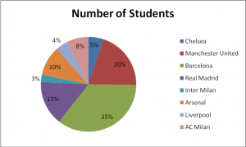](http://wizznotes.com/wp-content/uploads/2010/11/image018.png)

The Pie Chart above depicts each sector as percentages. To calculate the percentages for each sector use the formula below:

% of a sector      =             Number of students                       x              100

                                                Total number of students

So, to calculate the percentage of Chelsea fans:

% of Chelsea fans            =             50           x              100

                                                              990

% of Chelsea fans            =             5%

For Pie charts which depicts each sector as angles, the angles for each sector is found using the formula below:

Angle of a sector              =             Number of students                       x              360

                                                                Total number of students

So, to calculate the angle of the Chelsea sector:

Angle of Chelsea sector                                =             50           x              360

                                                                                                990

Angle of Chelsea sector                                =             18o

**Note**:    In most cases the questions set on Pie charts require those drawn depicting sectors in percentages.

**Line Graphs**

Line graphs are mostly used in depicting trends, and as such, values are in most cases plotted against time. A line graph is drawn by connecting a line to consecutive values, with a circle/point made at each value being depicted.

Example

The table below lists the amount of Toyota motor vehicles produced in the month of April over the period 2000- 2010.

|  |  |
| --- | --- |
| **Year** | **Number of Toyota Motor Vehicles Produced** |
| 2000 | 220,382 |
| 2001 | 260,879 |
| 2002 | 213,546 |
| 2003 | 238,890 |
| 2004 | 227,678 |
| 2005 | 245,376 |
| 2006 | 240,224 |
| 2007 | 224,100 |
| 2008 | 258,100 |
| 2009 | 248,024 |
| 2010 | 249,123 |

[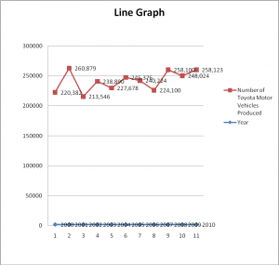](http://wizznotes.com/wp-content/uploads/2010/11/image019.png)

**WEEK 7 REVIEW OF FIRST HALF TERM’S**

**WEEK 8AND 9 PROBABILITY**

# PROBABILITY

|  |
| --- |
|  |
|  |

**Probability** is the [measure](https://en.wikipedia.org/wiki/Measure_%28mathematics%29) of the likelihood that an [event](https://en.wikipedia.org/wiki/Event_%28probability_theory%29) will occur. Probability is quantified as a number between 0 and 1 (where 0 indicates impossibility and 1 indicates certainty). The higher the probability of an event, the more certain we are that the event will occur. A simple example is the tossing of a fair (unbiased) coin. Since the coin is unbiased, the two outcomes ("head" and "tail") are equally probable; the probability of "head" equals the probability of "tail." Since no other outcome is possible, the probability is 1/2 (or 50%) of either "head" or "tail". In other words, the probability of "head" is 1 out of 2 outcomes and the probability of "tail" is also, 1 out of 2 outcomes.

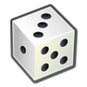

The probability of an [event](https://en.wikipedia.org/wiki/Event_%28probability_theory%29) *A* is written as P(A), p(A), or \text{Pr}(A).[[24]](https://en.wikipedia.org/wiki/Probability#cite_note-24) This mathematical definition of probability can extend to infinite sample spaces, and even uncountable sample spaces, using the concept of a measure.

The *opposite* or *complement* of an event *A* is the event [not *A*] (that is, the event of *A* not occurring), often denoted as \overline{A}, A^C, \neg A, or \sim A; its probability is given by *P*(not *A*) = 1 − *P*(*A*). As an example, the chance of not rolling a six on a six-sided die is 1 – (chance of rolling a six) = 1 - \tfrac{1}{6} = \tfrac{5}{6}. If two events *A* and *B* occur on a single performance of an experiment, this is called the intersection or of *A* and *B*, denoted as P(A \cap B).

### Independent events

If two events, *A* and *B* are [independent](https://en.wikipedia.org/wiki/Independence_%28probability_theory%29) then the joint probability is

P(A \mbox{ and }B) =  P(A \cap B) = P(A) P(B),\,

for example, if two coins are flipped the chance of both being heads is \tfrac{1}{2}\times\tfrac{1}{2} = \tfrac{1}{4}.[[26]](https://en.wikipedia.org/wiki/Probability#cite_note-26)

### Mutually exclusive events

If either event *A* or event *B* occurs on a single performance of an experiment this is called the union of the events *A* and *B* denoted as P(A \cup B). If two events are [mutually exclusive](https://en.wikipedia.org/wiki/Mutually_exclusive_events) then the probability of either occurring is

P(A\mbox{ or }B) =  P(A \cup B)= P(A) + P(B).

For example, the chance of rolling a 1 or 2 on a six-sided [die](https://en.wikipedia.org/wiki/Dice) is P(1\mbox{ or }2) = P(1) + P(2) = \tfrac{1}{6} + \tfrac{1}{6} = \tfrac{1}{3}.

### Not mutually exclusive events

If the events are not mutually exclusive then

P\left(A \hbox{ or } B\right)=P\left(A\right)+P\left(B\right)-P\left(A \mbox{ and } B\right).

For example, when drawing a single card at random from a regular deck of cards, the chance of getting a heart or a face card (J,Q,K) (or one that is both) is \tfrac{13}{52} + \tfrac{12}{52} - \tfrac{3}{52} = \tfrac{11}{26}, because of the 52 cards of a deck 13 are hearts, 12 are face cards, and 3 are both: here the possibilities included in the "3 that are both" are included in each of the "13 hearts" and the "12 face cards" but should only be counted once.

|  |  |
| --- | --- |
| **Event** | **Probability** |
| A | P(A)\in[0,1]\, |
| not A | P(A^c)=1-P(A)\, |
| A or B | \begin{align} P(A\cup B) & = P(A)+P(B)-P(A\cap B) \\ P(A\cup B) & = P(A)+P(B) \qquad\mbox{if A and B are mutually exclusive} \\ \end{align} |
| A and B | \begin{align} P(A\cap B) & = P(A|B)P(B) = P(B|A)P(A)\\ P(A\cap B) &  = P(A)P(B) \qquad\mbox{if A and B are independent}\\ \end{align} |
| A given B | P(A \mid B) = \frac{P(A \cap B)}{P(B)} = \frac{P(B|A)P(A)}{P(B)} \, |

**PROBABILITY SCALE AND TERMS**

* **EVENT:** An event is something that happens. Example tossing a coin or throwing a dice is an event.
* **OUTCOME:** An outcome is the result of an event. Example if you toss a coin, you will either get a Head or Tail. This means there are 2 possible outcomes.
* **IMPOOSSIBLE:** An event that is impossible will definitely happen is given a probability of 0.
* **UNLIKELY:** When the probability tends towards 0, then there is less chances that an event will happen.
* **LIKELY:** When the probability tends towards 1, then there is a likely chance that is 50-50

**APPLICATION**

**EXAMPLES:**

Each of the following numbers are writing on a piece of paper and then put in a bag. 3, 4, 6, 3, 5, 7, 5, 10, 5, 12, 7, 8 , 9 ,7, 5, 3, 9, 6, 6, 11, 12, 11, 5

What is the probability of a picking at random

1. An odd number
2. An even number

SOLUTION

Picking an odd number is 3, 5, 7, 11, successful outcome is 3, 3, 3, 5, 5, 5, 5, 5, 7, 7,7, 9, 9, 11, 11 = 15 outcome.

Pro. Of odd no = 15/24 = 5/8

Picking an even number is 4, 4, 6, 6, 6, 8, 10, 12, 12 = 9 outcome

Pro. Of even number is 9/24 = 3/8

Example 2: There are 7 red balls, 8 white balls and 5 blue balls in a box. Find the probability thst the ball is

1. White
2. Red
3. Blue or red
4. Neither red nor white
5. green

Solution:

1. Total number of balls = 7+ 8+ 5

= 20

White ball = 8, pro. Of selecting a white ball is = 8/20 = 2/5

1. Number of red balls = 7

Pro. Of selecting a red balls = 7

7/20

1. Number of blue and red balls = 5+ 7 = 12

Pro. Of selecting a blue or red ball = 12/ 20

3/5

1. If the ball is neither red nor white, then it must be blue. Pro. Of selecting a blue ball = 5/20 = ¼
2. There are no green balls therefore the pro. Of green is 0

Example 3: A card is selected from a well shuffled standard pack of 52 cards. What is the probability of getting,

1. A diamond
2. A queen
3. An ace
4. A red card
5. The ace of spades
6. Any card other than an ace

***NOTE: A PACK OF CARDS ARE IN 4 SUITS. EACH SUIT HAS 13 DIAMONDS, 13 HEARTS, 13 SPADES, 13 CLUBS. THE DIAMOND AND THE HEART ARE BOTH RED WHILE THE CLUB AND THE SPADE ARE BLUE. THE SIZE OF NUMBERS ON THE CARD ARE: A 2, 3, 4, 5, 6, 7, 8, 9, 10, J, Q, K.***

***WHERE A = ACE, Q = QUEEN, K = KING, J = JACK. THERE ARE 12 PICTURE CARDS, NAMELY; 4 KINGS, 4 QUEENS, 4 JACKS.***

Solution

Total numbers of possible outcomes = 52

(a). pro. (diamond) = 13/52

= ¼

(b). pro (Queen) = 4/52

= 1/13

(c). pro. (Ace) 4/52

= 1/13

(e). pro. (red card) = 26/52

= ½

(f). pro. (any card other than an ace) = 1- 1/13

= 12/ 13

**DO THESE**

1. A bag contains the following: 90 blue balls, 3 red balls, 50 yellow balls, 57 brown balls 100 green balls. What is the probability of picking at random:
2. A blue ball
3. A yellow ball
4. A brown ball
5. A red balls
6. A white ball
7. A green ball
8. A card is selected from a well shuffled standard pack of 52 cards. What is the probability of getting:
9. A club
10. The ace of diamond
11. A jack of hearts
12. A diamond or a spade
13. A die has six faces numbered 1 to 6. If the die is rolled once, find the probability of:
14. Obtaining the number 6
15. Obtaining the number 10
16. Not obtaining the number 6
17. Obtaining the numbers 1, 2, 3, 4, 5, or 6

**ASSIGNMENT**

**PAGE 308 EXERCISE 24.3 NO 1, 3, 4, 5, 6, 7, AND 8**